**FitFlex : Your Personal Fitness**

**Companion**(React Application)

**TEAM ID** : SWTID1741518878153635

**TEAM LEADER** : NIRMALA M

**TEAM MEMBERS** : MOHANA M

NASREEN B

POOJA A

**CLASS** : III-BSC COMPUTER SCIENCE

**EMAIL ID’S**  : nirmalamanoharan2003@gmail.com

Mohanamohana44314@gmail.com

[rizwanabasheercpt@gmail.com](mailto:rizwanabasheercpt@gmail.com)

poojaaru50@gmail.com

**FitFlex : Your Personal Fitness(React)**

# 

# INTRODUCTION:-

FitFlex: Your Personal Fitness App is a React-based web application designed to help users achieve their fitness goals through personalized workout plans, progress tracking, and interactive features. The app offers an intuitive and user-friendly interface, making it easy for beginners and fitness enthusiasts alike to navigate workout routines, set fitness goals, and track performance over time. Built with React, FitFlex ensures a seamless and responsive experience across devices, allowing users to access their fitness plans anytime, anywhere.

The core functionality of FitFlex includes customizable workout routines, AI-powered fitness recommendations, and real-time progress monitoring. Users can choose from a variety of workout programs, ranging from strength training to cardio and flexibility exercises, tailored to their individual fitness levels. Additionally, the app integrates with APIs for nutrition tracking, step counting, and heart rate monitoring, ensuring a holistic approach to health and fitness. With a focus on user engagement, FitFlex also includes motivational challenges, leaderboards, and social features to encourage consistency and accountability.

Developed using modern React technologies such as React Hooks, Context API, and Redux for state management, FitFlex provides a dynamic and scalable solution for fitness tracking. The app also leverages Firebase for authentication and cloud storage, ensuring secure access to user data. Future enhancements include AI-driven workout suggestions, integration with wearable devices, and a personalized diet planner. FitFlex aims to revolutionize the way users engage with their fitness journey, making workouts more accessible, efficient, and enjoyable.

With FitFlex, users can experience the transformative power of a healthy and active lifestyle. By leveraging the power of React and mobile app development, FitFlex provides a seamless and intuitive user experience that makes it easy to stay motivated and focused on your fitness goals. Whether you’re looking to lose weight, build muscle, or simply improve your overall health and well-being, FitFlex is the perfect companion to help you achieve your fitness objectives and live a healthier, happier life. By choosing FitFlex, you’re taking the first step towards a healthier, more active you.

**Scenario-Based Intro:-**

Imagine this: You wake up in the morning, determined to stay fit, but you’re unsure where to start. Do you hit the gym, go for a run, or try a home workout? With a busy schedule and countless fitness options, staying consistent feels overwhelming. That’s where FitFlex steps in—your personal fitness app that takes the guesswork out of working out. Whether you’re a beginner looking for guidance or a fitness enthusiast tracking progress, FitFlex creates a personalized experience tailored to your goals, schedule, and fitness level.

# Now, picture yourself opening the FitFlex app. It greets you with a custom workout plan based on your preferences, fitness history, and available time. You get guided video tutorials, real-time performance tracking, and AI-driven workout recommendations—all in one sleek and easy-to-use interface. Forgot to plan your meals? No worries! FitFlex also offers meal suggestions to complement your workout, ensuring a well-rounded fitness journey. Plus, with reminders and progress analytics, staying on track has never been this simple.

# Fast forward a few weeks—your energy levels are up, you’re feeling stronger, and most importantly, you’re staying consistent. The app keeps you motivated with fitness challenges, rewards, and community support, making workouts fun and engaging. Whether you prefer solo training or joining virtual group workouts, FitFlex adapts to your lifestyle, helping you achieve your fitness goals at your own pace. No more confusion, no more wasted time—just a smarter, more effective way to stay fit. Welcome to FitFlex, where fitness meets flexibility!

# Target Audience:-

**● Fitness Enthusiasts:** Individuals passionate about health and fitness who actively engage in workouts and physical activities to maintain a healthy lifestyle.

**● Beginners in Fitness:** People new to exercising who seek guidance, structured workout plans, and motivation to start their fitness journey.

**● Busy Professionals:** Individuals with demanding work schedules who need flexible, time-efficient workout routines that fit into their daily lives.

**● Home Workout Lovers:** Users who prefer exercising at home rather than going to the gym and look for virtual fitness programs and guided workouts.

**● Gym-Goers:** People who regularly visit gyms and seek additional support through workout tracking, exercise tutorials, and personalized training plans.

**● Health-Conscious Individuals:** Those focused on improving their overall well-being, including weight management, strength building, and mental wellness.

**● Athletes & Sports Enthusiasts:** Professional or amateur athletes looking for specific workout programs to enhance performance in their respective sports.

**● Elderly & Active Seniors:** Older adults who want to stay fit with low-impact exercises, mobility workouts, and wellness routines.

**● Post-Rehabilitation Patients:** Individuals recovering from injuries or medical conditions who require structured and guided fitness plans for safe recovery.

**● Yoga & Meditation Seekers:** People looking for holistic fitness approaches, including yoga, meditation, and mindfulness exercises.

# Project Goals and Objectives:-

The overarching aim of FitFlex is to offer an accessible platform tailored for individuals

Passionate about fitness, exercise, and holistic well-being.

Our key objectives are as follows:

**✔** **User-Friendly Experience:** Develop an intuitive interface that facilitates easy

Navigation, enabling users to effortlessly discover, save, and share their preferred

Workout routines.

**✔** **Comprehensive Exercise Management:** Provide robust features for organizing and

Managing exercise routines, incorporating advanced search options for a

Personalized fitness experience.

**✔** **Technology Stack:** Harness contemporary web development technologies, with a

Focus on React.js, to ensure an efficient and enjoyable user experience.

**Key Features of fitflex:-**

**✔ Exercises from Fitness API:** Access a diverse array of exercises from reputable fitness

APIs, covering a broad spectrum of workout categories and catering to various fitness

Goals.

**✔ Visual Exercise Exploration:** Engage with workout routines through curated image

Galleries, allowing users to explore different exercise categories and discover new

Fitness challenges visually.

**✔ Intuitive and User-Friendly Design:** Navigate the app seamlessly with a clean,

Modern interface designed for optimal user experience and clear exercise selection.

**✔** **Advanced Search Feature:** Easily find specific exercises or workout plans through a

Powerful search feature, enhancing the app’s usability for users with varied fitness preferences.

# TECHNICAL ARCHITECTURE:-

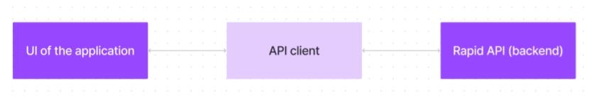

# FitFlex prioritizes a user-centric approach from the ground up. The engaging user interface(UI), likely built with a framework like React Native, keeps interaction smooth and intuitive.

# An API client specifically designed for FitFlex communicates with the backend, but with a twist: it leverages Rapid API. This platform grants access to various external APIs, allowing FitFlex to potentially integrate features like fitness trackers, nutrition data, or workout Tracking functionalities without building everything from scratch. This approach ensures a Feature-rich experience while focusing development efforts on the core FitFlex functionalities.

# PRE-REQUISITES:-

Here are the key prerequisites for developing a frontend application using React.js:

**✔ Node.js and npm:**

Node.js is a powerful JavaScript runtime environment that allows you to run

JavaScript code on the local environment. It provides a scalable and efficient

platform for building network applications.

Install Node.js and npm on your development machine, as they are required to run

JavaScript on the server-side.

● Download: https://nodejs.org/en/download/

● Installation instructions: https://nodejs.org/en/download/package-manager/

**✔ React.js:**

React.js is a popular JavaScript library for building user interfaces. It enables

developers to create interactive and reusable UI components, making it easier to

build dynamic and responsive web applications.

Install React.js, a JavaScript library for building user interfaces.

**● Create a new React app:**

npx create-react-app my-react-app

Replace my-react-app with your preferred project name.

**● Navigate to the project directory:**

cd my-react-app

**● Running the React App:**

With the React app created, you can now start the development server and

see your React application in action.

**● Start the development server:**

npm start

This command launches the development server, and you can access

Your React app at <http://localhost:3000> in your web browser.

**✔ HTML, CSS, and JavaScript:** Basic knowledge of HTML for creating the structure of Your app, CSS for styling, and JavaScript for client-side interactivity is essential.

**✔Version Control:** Use Git for version control, enabling collaboration and tracking Changes throughout the development process. Platforms like GitHub or Bitbucket can Host your repository.

**• Git:** Download and installation instructions can be found at:

<https://git-scm.com/downloads>

**✔ Development Environment:** Choose a code editor or Integrated Development Environment (IDE) that suits your preferences, such as Visual Studio Code, Sublime Text, or WebStorm.

• Visual Studio Code: Download from <https://code.visualstudio.com/download>

• Sublime Text: Download from <https://www.sublimetext.com/download>

• WebStorm: Download from <https://www.jetbrains.com/webstorm/download>

To get the Application project from drive:

Follow below steps:

**✔ Get the code:**

• Download the code from the drive link given below:

<https://drive.google.com/drive/folders/1COHZXrSGctuYJXZ6Mc1onPtHNhzST-NH?usp=sharing>

**Install Dependencies:**

• Navigate into the cloned repository directory and install libraries:

Cd fitness-app-react

Npm install

**✔ Start the Development Server:**

• To start the development server, execute the following command:

npm start

**Access the App:**

• Open your web browser and navigate to http://localhost:3000.

• You should see the application's homepage, indicating that the installation

and setup were successful.

You have successfully installed and set up the application on your local machine. You can

now proceed with further customization, development, and testing as needed.

**PROJECT STRUCTURE:-**

In this project, we’ve split the files into 3 major folders, Components, Pages and Styles. In The pages folder, we store the files that acts as pages at different URLs in the application. The components folder stores all the files, that returns the small components in the Application. All the styling css files will be stored in the styles folder.

## 

**Project Execution:**

**Project demo:**

Before starting to work on this project, let’s see the demo.

Demo Link:

<https://drive.google.com/file/d/1SFerop9g3-dbvPbIQMa_z5I0sBnaAK2k/view?usp=sharing>

Use the code in:

<https://drive.google.com/drive/folders/1COHZXrSGctuYJXZ6Mc1onPtHNhzST-NH?usp=sharing>

**Milestone 1: Project Setup and Configuration:**

* **Installation of required tools:**

To build the FitFlex app, we’ll need a developer’s toolkit.

The following are the tool kits:

* React Js
* React Router Dom
* React Icons
* Bootstrap/tailwind css
* Axios

● **For further reference, use the following resources**

* <https://react.dev/learn/installation>
* <https://react-bootstrap-v4.netlify.app/getting-started/introduction/>
* <https://axios-http.com/docs/intro>
* https://reactrouter.com/en/main/start/tutorial

**Milestone 2: Project Development:**

❖ Setup the Routing paths

❖ Develop the Navbar and Hero components

❖ Code the popular search/categories components and fetch the categories from rapidAPI.

❖ Additionally, we can add the component to subscribe for the newsletter and the Footer.

❖ Now, develop the category page to display various exercises under the category.

❖ Finally, code the exercise page, where the instructions, other details along with Related videos from the YouTube will be displayed.

**Important Code snips:**

* **Fetching available Equipment list & Body parts list**

From the Rapid API hub, we fetch available equipment and list of body parts withan API request.

Dependencies:

The code utilizes the following libraries:

Axios: A popular promise-based HTTP client for JavaScript. You can add a link To the official documentation for Axios <https://axios-http.com/>

* **Fetching exercises under particular category**

To fetch the exercises under a particular category, use the rapidapi key.It defines a function called fetchData that fetches data from an exercise databaseAPI.

* **Fetching Exercise details**

Now, with the help of the Exercise ID, we fetch the details of a particular exercise with API request.The code snippet demonstrates how to fetch exercise data from an exercise Database API using JavaScript’s fetch API.

* **Fetching related videos from YouTube**

Now, with the API, we also fetch the videos related to a particular exercise with Code. The code snippet shows a function called fetchRelatedVideos that fetches data from YouTube using the RapidAPI service.

**Project Execution:**

After completing the code, run the react application by using the command “npm Start”.

The following are the screenshots of the project execution,

* Hero component
* About
* Search
* Category page
* Exercises page
* YouTube videos related to the exercises

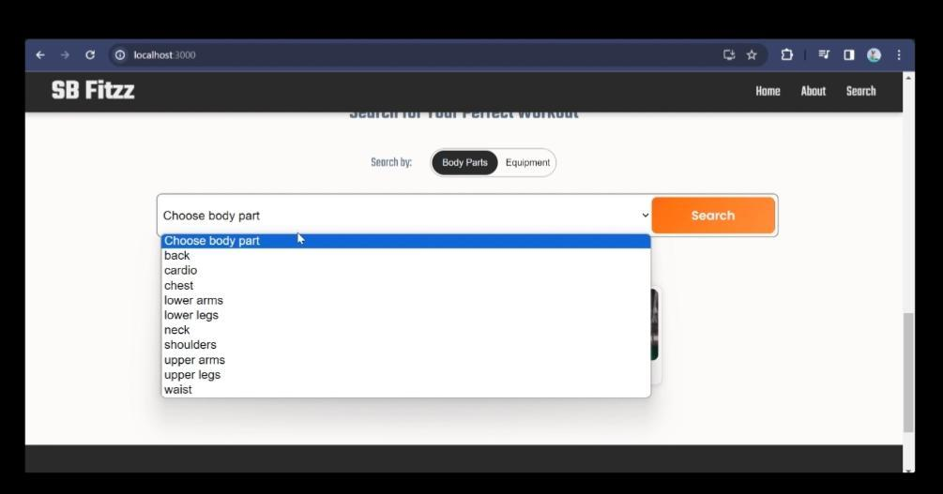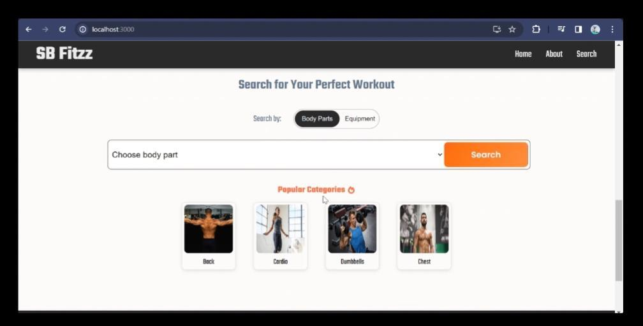

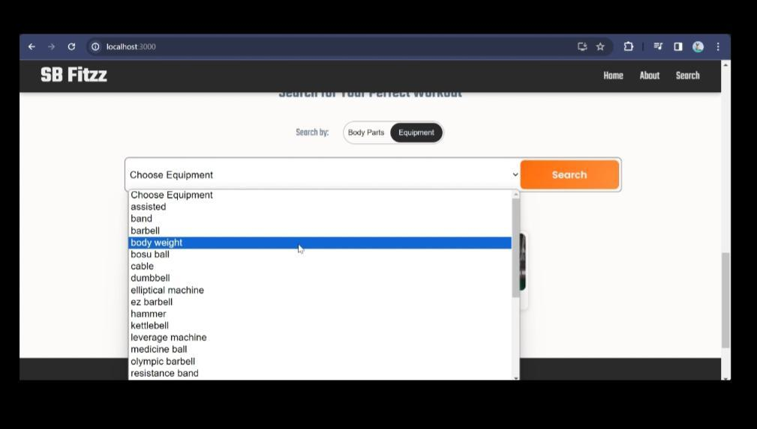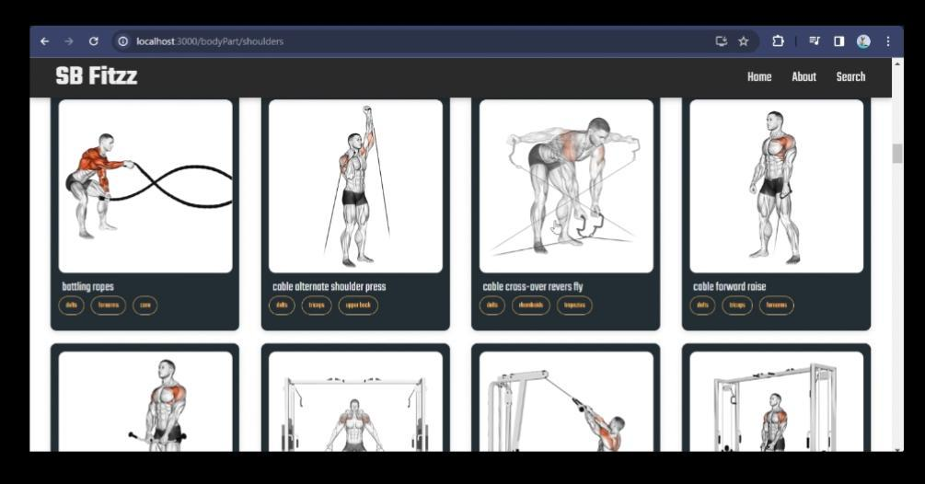

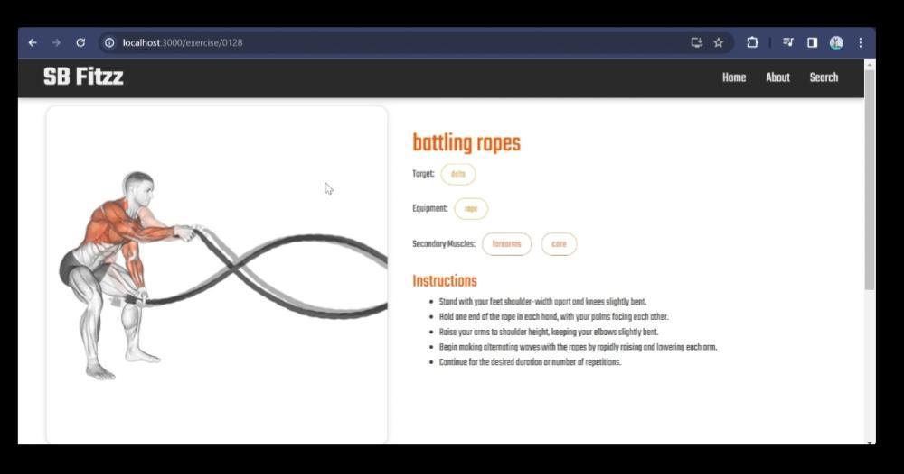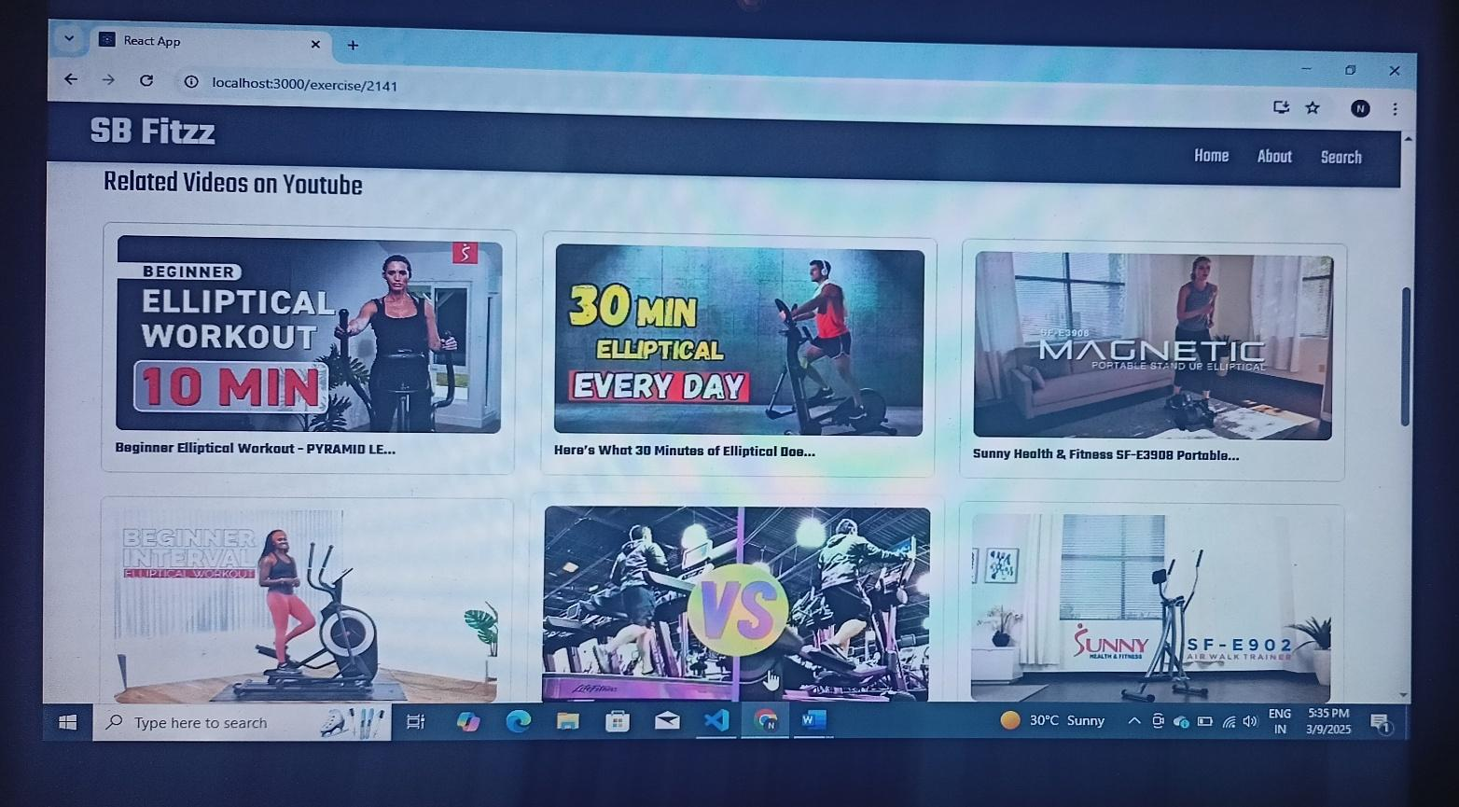

Demolink: <https://drive.google.com/file/d/1SFerop9g3-dbvPbIQMa_z5I0sBnaAK2k/view?usp=drive_link>